Giant hogweed! Japanese knotweed! And Phragmites! Oh my!
One will burn you, one can crack the foundation of your house, and the other will grow a 14-foot-high wall between you and your waterfront. It sounds like Little Shop of Horrors part 2!
They are all non-native, invasive plants, and they are right here in Magnetawan. Non-native means they have been introduced from another part of the world. Invasive means they have the ability to outcompete many of our native plants. They can thrive in our environment and are generally free of natural predators or diseases that would otherwise keep them in check. They are destroying our native habitats and reducing the diversity of our natural world.
If you compare these plants to our native species the problem becomes clear. Our native plants provide insects, birds, and wildlife with pollen, nectar, seeds, edible leaves, roots and shoots, and shelter. The worst non-native, invasive plants do none of the above and they will crowd out the plants that do.
So now it’s time to meet the bad three in Magnetawan.
Giant hogweed. This character has few redeeming qualities. They call it a giant because it can grow up to 14 feet tall. It is dangerous because it produces a noxious sap that can cause severe and painful burning and blistering of the skin when exposed to sunlight. It is related to, and can look a lot like, cow parsnip and wild parsnip only much larger with small white flowers clustered in an umbrella shaped head up to a foot across. Many plants in this family, even the native ones, can cause skin irritation, so best to avoid them if you are at all uncertain as to which plant is which.
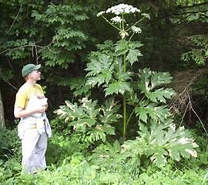
Photo credit: allthatsinteresting.com
Japanese knotweed. Think ornamental bamboo. This plant has a very aggressive root system that can spread up to 10 metres from the parent plant and can even grow through concrete and asphalt. The stalks grow straight up and can get quite tall. Up to 3 metres! The stems are round, reddish-purple in colour, and the leaves have a distinctive large, heart-shaped pattern. They zig-zag along the hollow stems of the plant. It is an attractive plant that likely escaped from gardens. Unfortunately, many of the worst non-native, invasive plants were introduced as innocent garden plants.
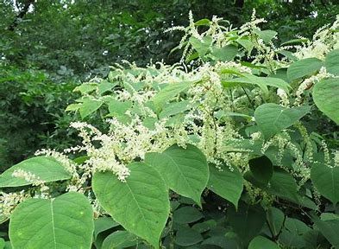
Photo credit: gardenista.com
Phragmites. Also known as reed canary grass. This one most of you have seen even if you didn’t know it. The next time you are driving highway 11, look for the incredibly tall grasses with fluffy heads in the ditches. That is phragmites. It has a native cousin, but the closer you are to major roadways the more likely it is to be the non-native variety. Also planted for ornamental purposes, this little escape artist will grow in any wet area including ditches, beaches, shorelines, and wetlands . It will even grow in the dry fringes of shorelines and wetlands . It is so aggressive that it forms dense stands of 200 stems per square metre. So dense you couldn’t fight your way to the beach with a machete. Nor could a turtle looking for a nesting spot. She will often die of thirst or starvation when caught up in this jungle of stems.
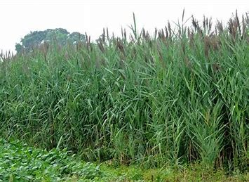
Photo credit: freep.com
There are parts of the Province where one or more of these plants have become a very big problem. Phragmites has the worst reputation, as it grows in prime recreational areas. As such it has mobilized many communities in an effort to eradicate it. Complete eradication is incredibly challenging. Each of these plants can regrow from tiny bits of root. There are ways however and the diligent efforts of many are having an impact. A community group is tackling phragmites up on Lake Bernard and other efforts have been on-going across the Province for years.
Controlling these plants according to their own vulnerabilities is the only solution and being aware of them is the first step. For those of you with a keen interest in gardening, be aware of what you are planting so that you don’t accidentally help to spread non-native, invasive plants in your area.
The bad three listed above aren’t the only ones plaguing our environment. Periwinkle is a common one in Magnetawan. It can creep its way through very shady woodlands choking out native plants along the way. Lily of the Valley and non-native phlox top out the list with these last ones being very popular with gardeners. But only for awhile. These plants are a challenge for even the most diligent gardener to control. Instead consider planting species native to Ontario. They support our pollinators, birds, and other wildlife in many ways.
There is so much more we can all learn about non-native, invasive species, so please check out a couple of sites listed below.
http://www.invadingspecies.com/
https://www.muskoka.on.ca/en/live-and-play/Invasive-Species.aspx
You can also learn more about the Magnetawan Watershed Land Trust on our website at www.mwlt.org or check us out on
Facebook @MagnetawanLandTrust;
Instagram @magnetawanlandtrust;
Twitter @magwlt
Mike Peppard
Stewardship and Communications Coordinator
Magnetawan Watershed Land Trust

