The Spring Melt – second installment in the ‘understanding out watershed’ series.
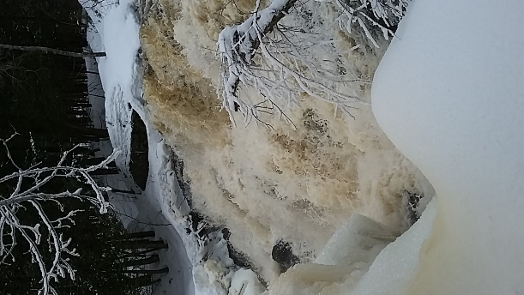
Photo: Mike Peppard
Arguably the most important time of the year for our watershed is the spring melt or ‘freshet’. Freshet means the flooding of a river with heavy rain or snowmelt.
It can be small and brief in places with little snow cover and a quick spring warm up, or big and drawn out, as is usually the case in the Magnetawan watershed, where the warm up is gradual and the snowpack quite substantial.
A gradual melt is preferred as it allows more time for the ground to thaw and absorb water while still allowing for some flooding along shorelines and stream banks. Spring flooding, while worrisome to people, plays a vital role in the health of the entire watershed.
The spring freshet fills up large wetlands close to rivers and lakes and small seasonal wetlands deep in the forest. As such, many amphibians and insects are able to lay their eggs in the relative safety of these small woodland pools that are free of fish and other predators. Wetlands, in turn, help to reduce flooding downstream by holding onto water. They also give back water to forests and streams through the hotter, drier summer months.
Meltwaters bring nutrients to riverbanks, shorelines, wetlands, and lakes, all of which feed the growth of plants and other organisms. Unfortunately meltwaters can also pick up a number of harmful substances left behind by people and wash them into waterways. These include oil and gas on roads and parking lots, and road salt, which is toxic to many organisms.
Climate change and other human activities such as the infilling of wetlands and removal of plants along shorelines are having an impact on the spring freshet. Wild swings in weather can accelerate snow melt and bring record flooding, as happened in the spring of 2019. Filling in wetlands, even the small ones, impacts wildlife and the health of forests and streams. Hardening shorelines with rock or concrete in place of native plants can force floodwaters downstream where the impact will be worse.
Thank you for reading, and look for more MWLT articles on our watershed each month as well as our speaker series on our watershed.
Mwlt.org
Facebook@MagnetawanLandTrust;
Instagram@magnetawanlandtrust;
Twitter@magwlt
Mike Peppard
Stewardship and Communications Coordinator
Magnetawan Watershed Land Trust

